user

gayazahamed

[http://training.mulesoft.com/login.html](http://mulesoft.cmail19.com/t/i-l-ukdthhl-qhkjiijn-j/)

http://anypoint.mulesoft.com

raml.org

API

Design first approach

anypoint platform

hybrid integration platform uses api led connectivity

design api designer

simulate -api console

feed back -api portal

exchange to disconver

validation mockout use case  api notebook

build anypoint studio

munit to test

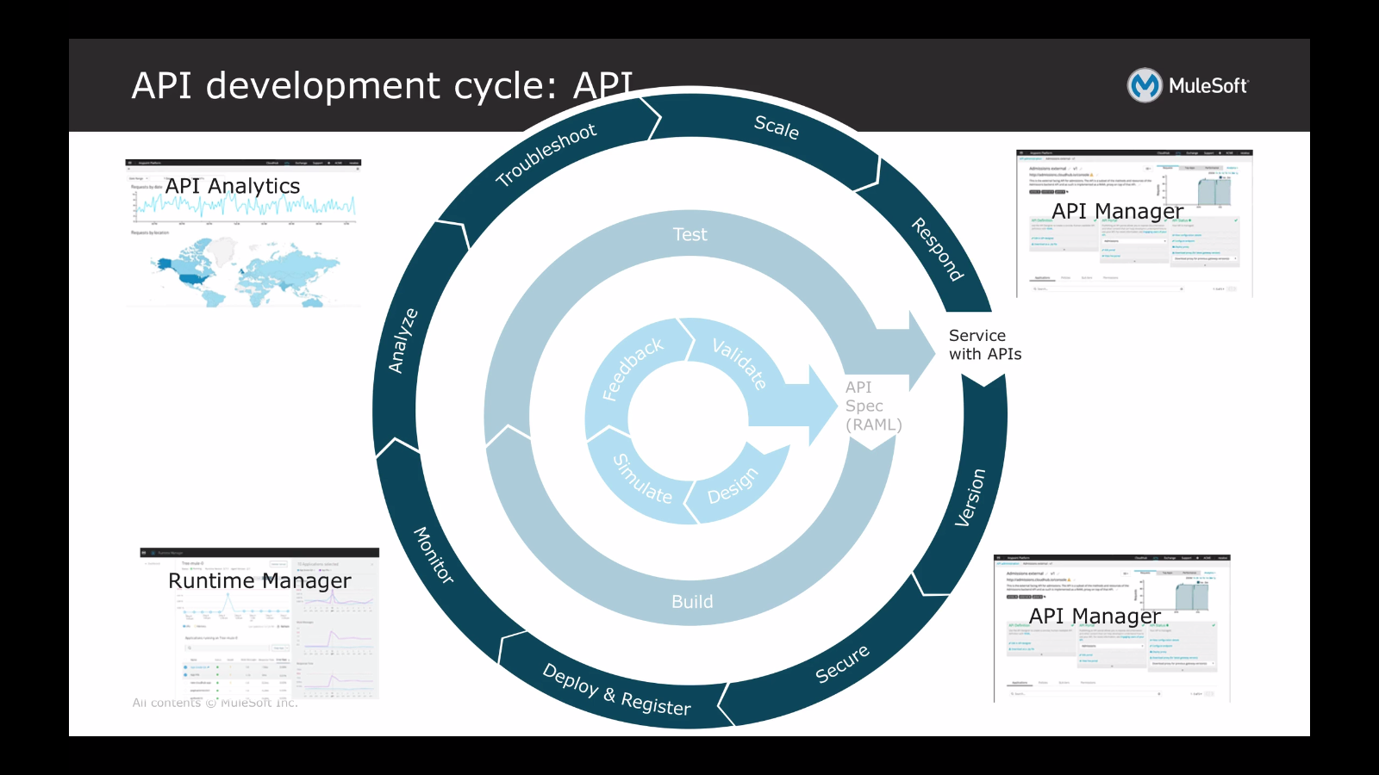

versioning & secure - api manager

deploy register /moniter - runtime manager

analatics troubleshoot  - Api analytics

scale - runtime manager

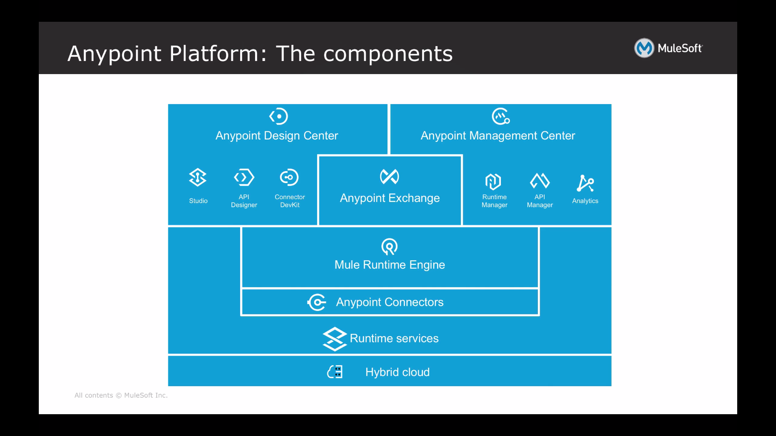

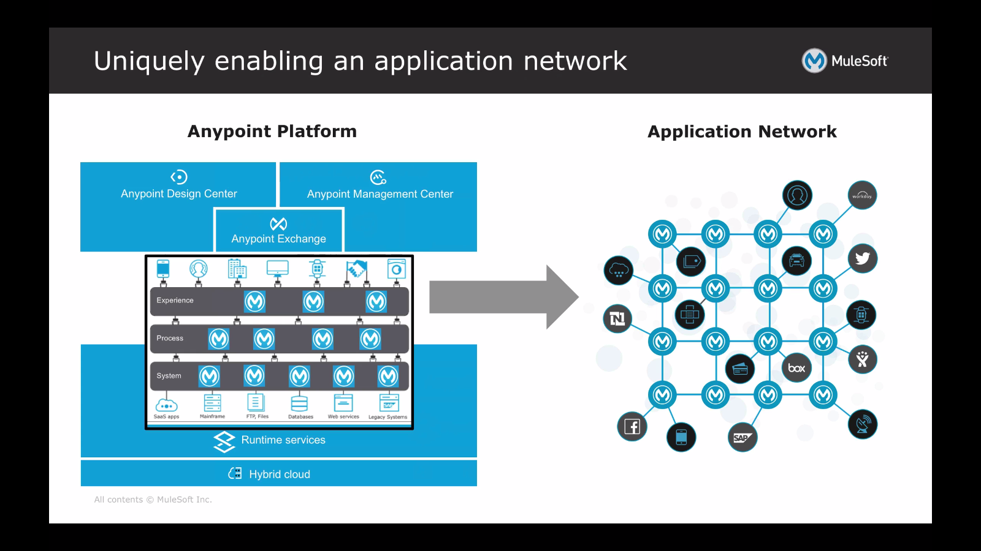

http://Anypoint.mulesoft.com

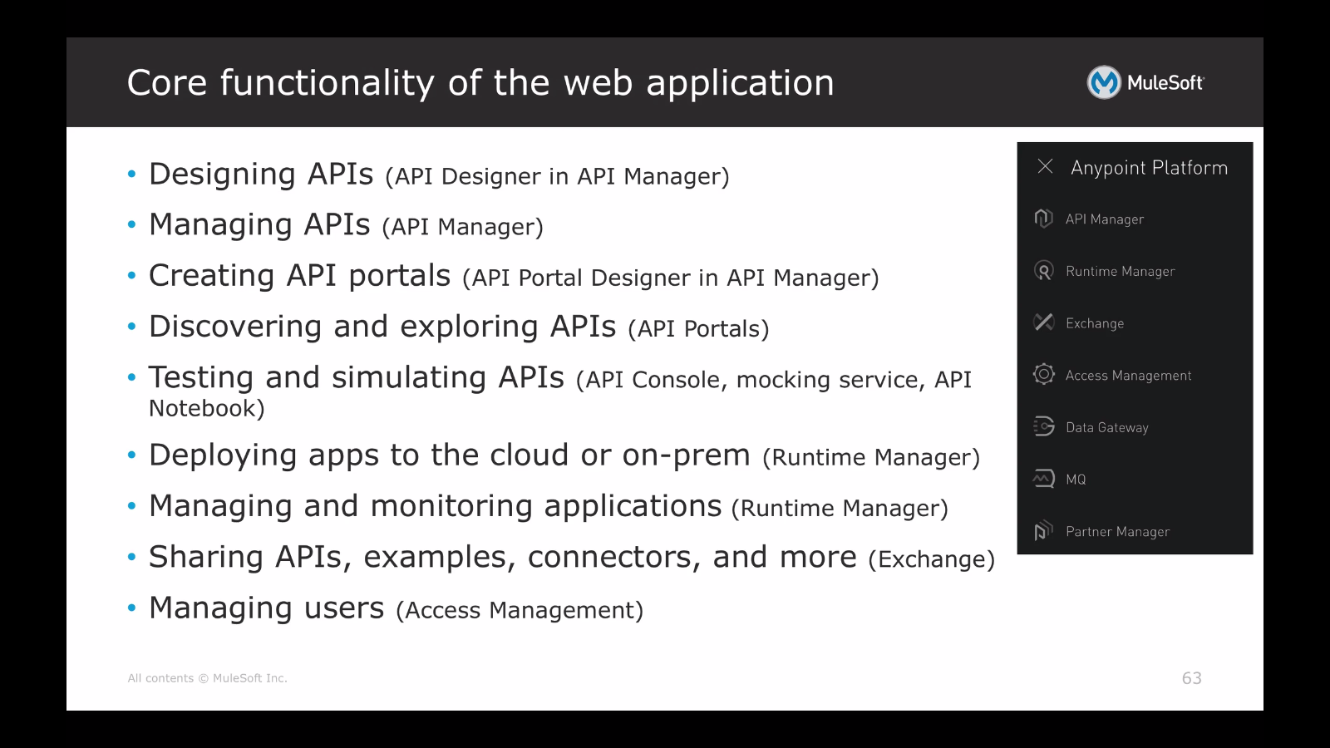

RAML

Uses YAML and json

